 

**Placement Empowerment Program**

***Cloud Computing and DevOps Centre***

* **Use Cloud StorageCreate a storage bucket on your cloud platform and upload/download files. Configure access permissions for the bucket**

Name: Sanjay Raj S Department : IT



**Prerequisites:**

* Google Cloud Platform (GCP) account. ytn installed on your local machine.

**Set Up a Google Cloud Project:**

* Go to e [Google Cloud Console](https://console.cloud.google.com/).
* Creaa w project or select an existing one.

**2. Ena the Cloud Storage API:**

* In the [APIs Services Dashboard](https://console.cloud.google.com/apis/dashboard), click on "Enable APIs and Services."
* Search forlo Storage" and enable it.

**3. Set Up Auntication:**

* Navigate to the [Svice Accounts](https://console.cloud.google.com/iam-admin/serviceaccounts) page.
* Create a new sere count with the "Storage Admin" role.
* Generate a JSON keyr is service account and download it to your machine.

**4. Install the Googleoud Storage Client Library:**

* It's recommended to use a vtual environment to manage your Python packages.

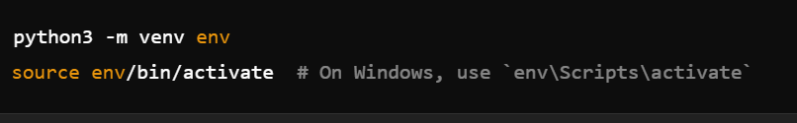

Install the client library:



**5. Set Up Authentication in Your lication:**

* Set The `GOOGLE_APPLICATION_CREDENTIALSenvironment variable to point to your service account key file:



Replace /path/to/your/service-account-e.jn with the actual path to your JSON key file.

**6. Using Google Cloud Storage in Python:**

Here's a sample script demonstrating how to uplo and download files:

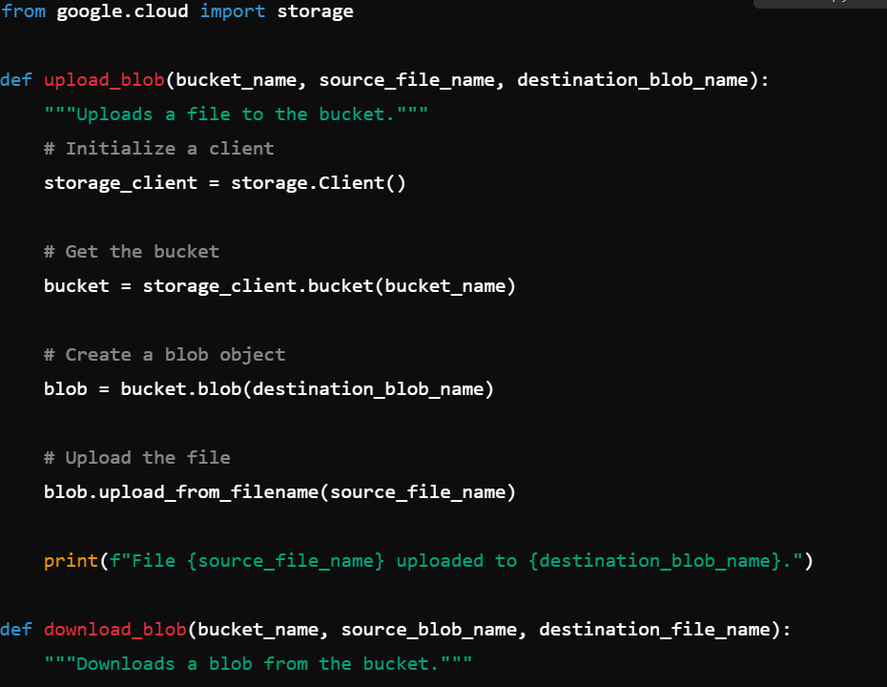 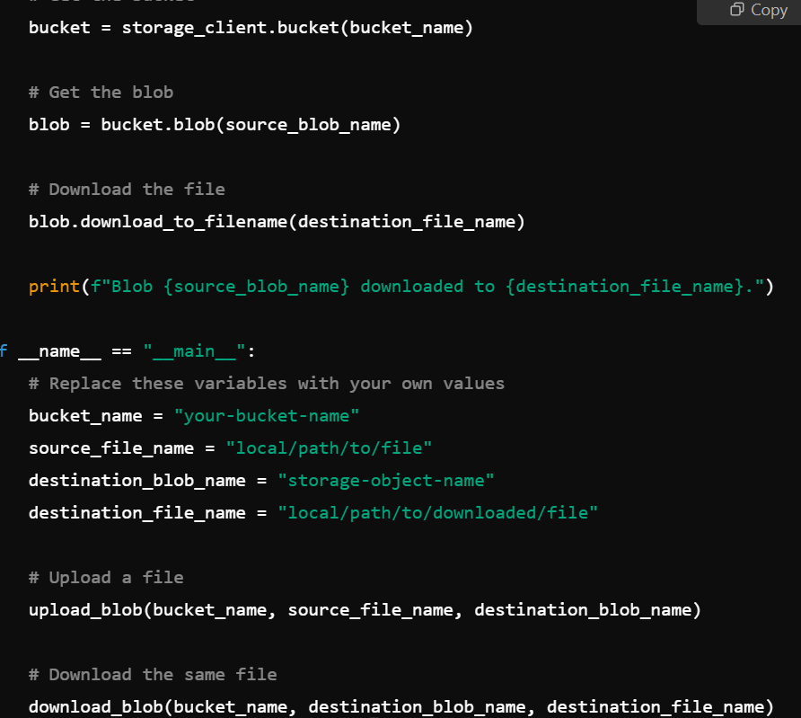

**Note:** Ensure that the bucket_name you spec already exis in your GCP project. You can create a new bucket via the [Cloud Console](https://console.cloud.google.com/storage) or using the gsutil command-line tool.

**7. Running the Script:**

* Save the script to a fi for example, gcs_example.py. Run the script:

* The script will uad local file to your specified Cloud Sa bucket and then download it back to your local machine.

**Additional Resources:**

* [Google Cloud Storage Client Librarycumentation](https://googleapis.dev/python/storage/latest/index.html)
* [Google Cloud Storage Python API Reference](https://cloud.google.com/python/docs/reference/storage/latest)

**Conclusion**

By following these steps, you can integrate Google Cloud Storage intoour Python applications, enabling efficient file storage and retrieval.